Amazing Natures - Website Requirements Document

1. Company Information
Brand Name: Amazing Natures

LOGO :



Business Type: Honey / Natural Products
Brand Description: Premium Australian cold pressed Manuka Honey brand focused on purity, potency, and wellness. All products are cold-extracted and lab-tested for quality assurance.

2. Products Information
All products are 250g jars.
MGO 263 - $40

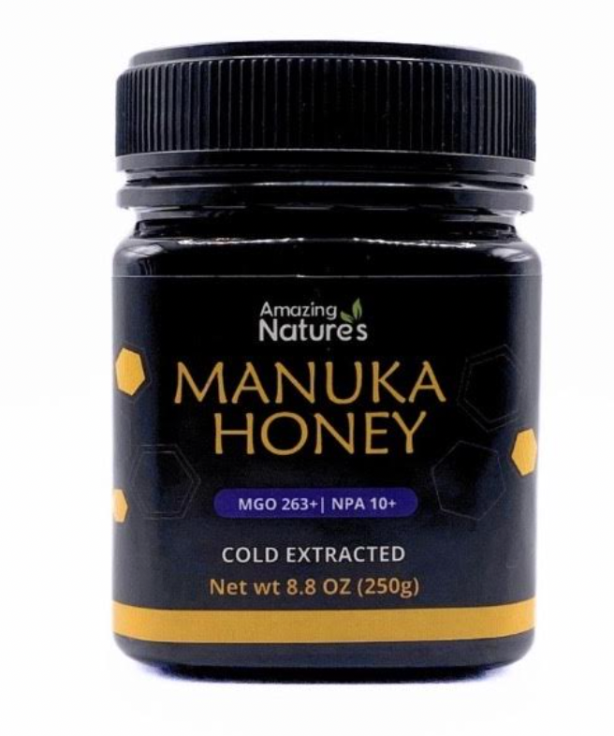

Cold-extracted Australian Manuka honey with high antibacterial properties based on MGO level.
MGO 400 - $70
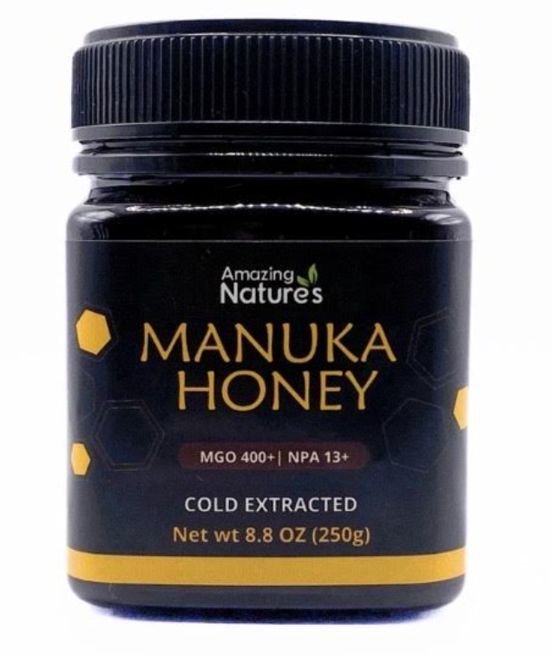

Cold-extracted Australian Manuka honey with high antibacterial properties based on MGO level.
MGO 800 - $160
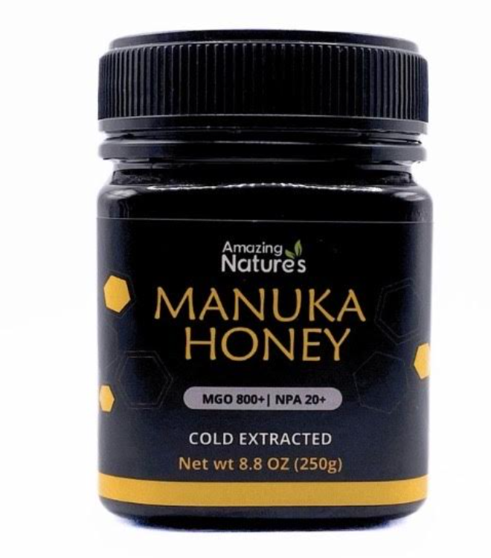

Cold-extracted Australian Manuka honey with high antibacterial properties based on MGO level.
MGO 30 - $14
Entry-level Manuka honey for daily use and general wellness.
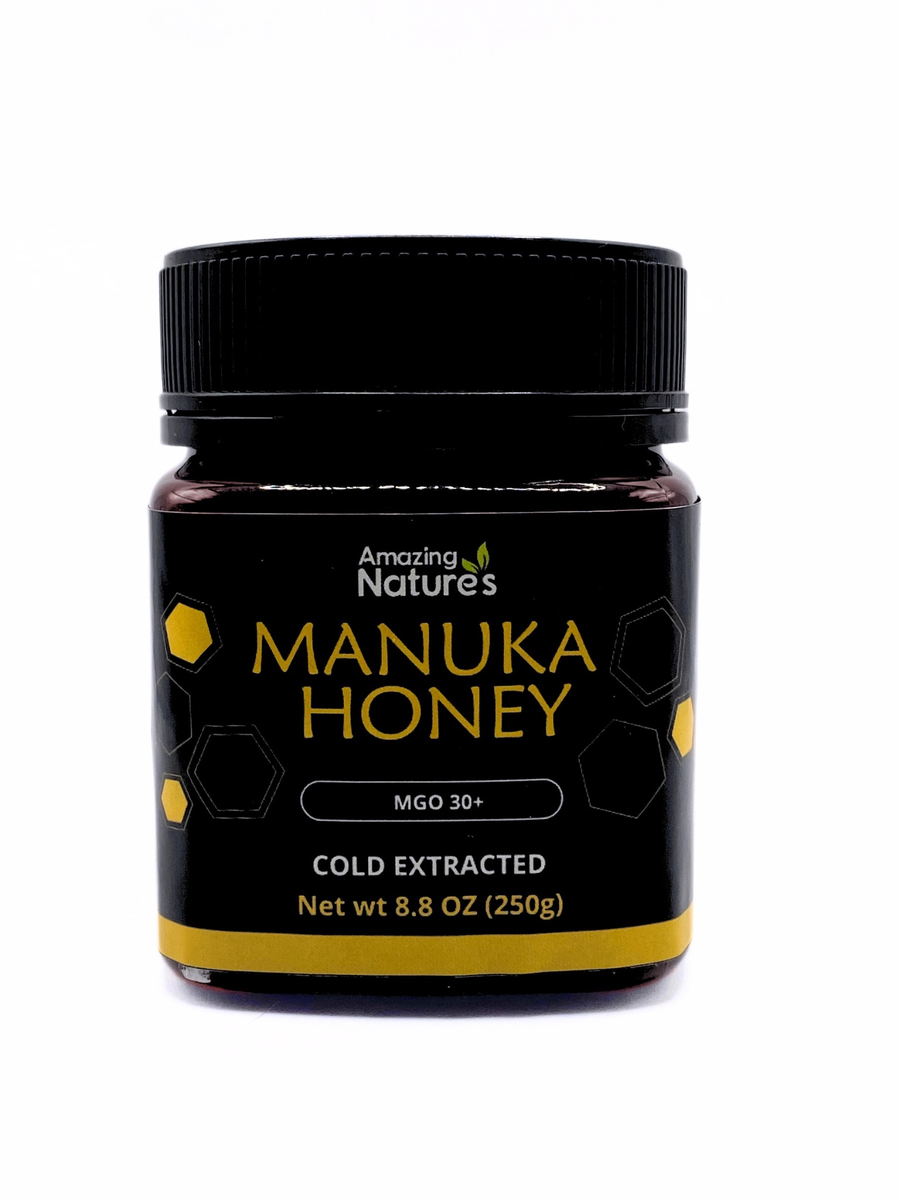

Cold-extracted Australian Manuka honey with high antibacterial properties based on MGO level.
MGO 100 - $18
Moderate strength Manuka honey suitable for regular health support.

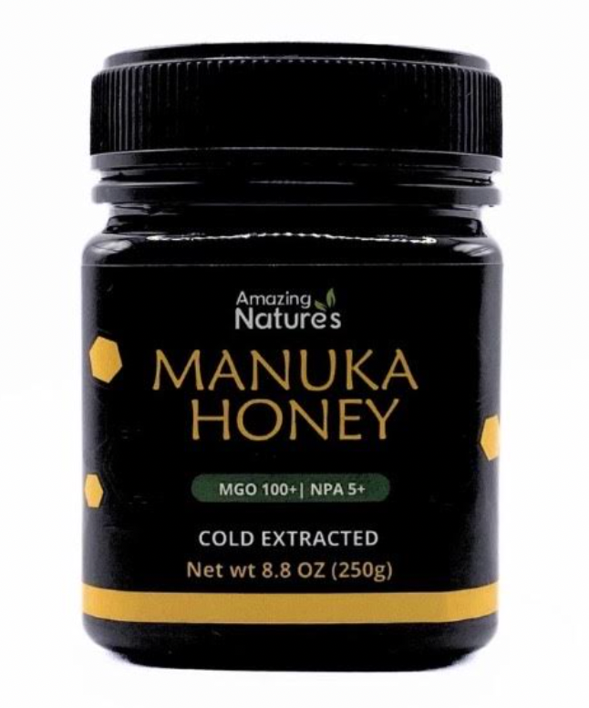

3. Pricing Details
MGO 30 - $14
MGO 100 - $18
MGO 263 - $40
MGO 400 - $70
MGO 800 - $160
Discounts: Seasonal offers available. Wholesale: Available on request.

4. Benefits & Content
Health Benefits: Boosts immunity, supports digestion, antibacterial properties, aids wound healing. Why Choose Us: Premium sourcing, lab-tested, high MGO ratings, trusted quality.
Lab test for American foul brood provided

5. Contact Information
Phone: 0405 686 486
WhatsApp:
Email: zeeshan.ahmed2691@gmail.com, note once website created domain email will be created

